Liberation of Garabagh
Ya Qarabağ, ya ölüm

Technical Document
(Homework No.3)

Project team: Gamers
Instructor: Dr. Araz Yusubov

Submitted in partial fulfillment of the requirements of the CSCI 4836: Game Development Fundamentals course project

Version date | Version information
13.11.2018 | Initial draft
18.11.2018 | Final Draft

Other documents in the package
File name | Brief description of the document
<File name> | <Description of the document>
<File name> | <Description of the document>

Team member | Contribution to this homework (NOT the project) | Estimated %
Nezir Yunuszada |  | 25 %
Arzu Mammadova |  | 25 %
Zohrab Musayev |  | 25 %
Semed Semedzade |  | 25 %

Table of Contents
<Automatically generate here using Microsoft® Word menu References→Table of Contents>

Introduction
This is part of the Game Design Document for a hypothetical project Liberation of Garabagh, submitted for partial fulfillment of the requirements of the Game Development Fundamentals course in the School of Information Technologies and Engineering at ADA University, Baku, Azerbaijan.

This file consists of all the necessary technical elements of the game including System Requirements, both the visual and audio aspects of the game. As a last part, it includes Programming Content which specifies organized collaboration with the programmer.

System Requirements

The list of the major system requirements includes the below-mentioned points:
- Firstly, the game is going to be available for Windows Operating System; therefore, a device should have Windows OS to run the game.
- Furthermore, the RAM memory will be 512MB for Windows.
- Moreover, the processor requirement will be Intel Core 2 Duo.
- And the last point is about required size for the hard disk which is about 500 MB.

Concerns and Alternatives

Talking about problems, we can mention issues regarding the most considerable aspect to make our product successful - advertising. It is considered expensive, especially when people are on a budget, so we are trying to use other alternative ways like social media, but still we are looking for more efficient paths and methods.

Resources

While developing the game we use the following equipment:
- Unity (as a main developing tool of the game)
- Visual Studio 2017 (as a compiler)

Visual Content
This section lists all the technical requirements from those in concerned with the visual aspects of the game.
- General
  - File Size Restrictions
The game size will be around 500MB if to consider each one of the 50 units of the objects to be 10 MB in size and to consist of prefabs, textures, and images as well.
  - File Format Type
During the game you can observe png, ogg file formats.
  - File Quality Type
Talking about quality, we can say that the screen resolution will be 1024x1024 as a default, highlighting its accordance both with PC and Laptop screens.

  - Visual Scale
As mentioned before, it will be appropriate both for PC and Laptop scales.
- Player Elements
  - An animation Frame here is the tank itself.
  - For our game we will have two types of the states which are Alive and Destroyed. Firstly, while our player is in alive state, Armenian tanks will move toward the player. The second destroyed state says that when player exterminates them with the fire shot down to 0 percent health, they will not be able to move further.
- Heads Up Display (HUD)
  - In this part, we will have icons for Health, Bullets and Pause, where Health and Bullets stand to see the details about the current state and a Pause button will appear on the screen to make a pause or to go to the Menu bar.
  - In the HUD part we will have states for welcoming page, a pause menu and a playing screen itself which is shown during the game.
  - Font Type of the game elements is Cambria.
- Antagonistic Elements
  - The states that we have for Antagonistic elements are again Alive and Destroyed. If an Armenian tank (which is an antagonistic player in our case) is in alive state, then Azerbaijani tanks can move toward the player. If an Armenian tank is in destroyed state, it will not be able to move further.
  - An animation frame for Armenian tanks are Azerbaijani tanks (and vice versa).
- Global Elements
  - As a background global element we can specify the village along with its houses, mountains, trees and a lake.
  - Font Type of the game elements is Cambria.

Audio Content
<This is the section for organizing the audio content. It is very important to communicate with the audio designer before and while the audio content is being developed.
- General
  - File Size Restrictions
  - File Format Type
  - File Quality Type
- Player Elements
  - Type of Sound f/x
  - Device Vibration
- Antagonistic Elements
  - Type of Sound f/x
  - Device Vibration
- Global Elements
  - Ambient Music
- Splash Screens
  - Ambient Music
- Menus
  - Type of Sound f/x
>

Programming Content
The main target of this section includes good collaboration of the programming content of the game.
- General
  - Requirements
The requirements which are mentioned below:
Graphics card: The game does not require any powerful GPU because we do not have objects that need complex functions. They just play simple visual role.
Operating System: The game will be available for only Microsoft Windows platform. Playing tank games is not convenient for smart phones.
Memory: The 512MB RAM is enough for playing the game. It does not require so much memory space.
Processor: The game requires Intel Core 2 Duo for Windows platform devices.
Hard Disk: Approximately, the game volume will be around 500MB.
  - File Size Restrictions
The game size will be around 500MB that is considered to be 50 units of objects and each of them should be 10MB in size that consist of prefabs, textures, and images.
  - File Format Type
There are .cs(C# scripts), .png, .mp3, .ogg file formats in the game.
  - Specify Coding Conventions
  - Language/Device Restrictions
The main language of the game is English. Taking into the consideration that our game belongs to Garabagh, from patriotic view, it is preferable to have an option for Azerbaijani language in the game.
  - Screen Type (Small, Medium, Large)
Screen resolution will be as default 1024x1024 and it will be suitable both for PC and Laptop screens. Additionally, user can change the screen resolutions from settings to make comfortable view for himself/herself.
- Player Elements
Reach to the fortress
  - Our player involves specific functions that define game play actions. First of all, the tank should be able to move in a 3D platform through the help of arrow keys and alternatively “W”, “S”, “A”, “D” buttons. Moreover, the player will be able to shoot enemy thank by pressing the “SHIFT”. Additionally, player includes functionality to put the bomb via the “SPACE BAR”. We utilize the “OnCollisionEnter” function to detect that we have already reached the fortress.

- Antagonistic Elements
  - Pathfinding
The only antagonistic elements of our game are the enemy tanks. Enemy tanks have AI elements like pathfinding which know the location of our main character and detect it. Shootings from enemy tanks will affect the health of our player.
- Global Elements
  - Making the game challenging
Global elements of our game include houses, trees, and bridges. All these elements will help to make the game more interesting, more challenging because each of them has the box collider. It will help to protect our tank against enemy shooting and vice versa.
- Splash Screens
Change between scenes.
  - In splash screen, there will be a logo which consists of a tank and an Azerbaijani flag including the loading property. The logo will have specific duration within the “isFinished()” method. “Draw()” method renders the logo in a splash screen. After the duration finishes, it automatically changes to the main menu screen. So, as the main functionality of splash screen, main menu will appear after it faded out.
- Menus
Load new screen
  - Menu section includes the “Start Game”, “Options”, “Tank Shop”, “Exit Game”. As we said, the main menu will appear after the splash menu. In the main menu, by clicking “Tank Shop”, player will chose available tanks from the general list. The tanks will have different properties as speed and power. With the help of the options button, sound, graphics will be adjusted.
  - Type of Options
“Start Game”, “Options”, “Tank Shop”, “Exit Game”.

Code Structure

“OnCollisionEnter()” – This function checks whether our tank has reached the “Shusha” fortress or not.
“PutBombs()” - This function is used for placing the bomb into the area to create obstacles for antagonistic elements.
“UpgradeFuel()” – The function maintains for upgrading the level of fuel indicator.
“Shoot()” - It will be utilized for shooting antagonistic elements.

Bonus: Below you can see a Class Diagram that we draw for our game.

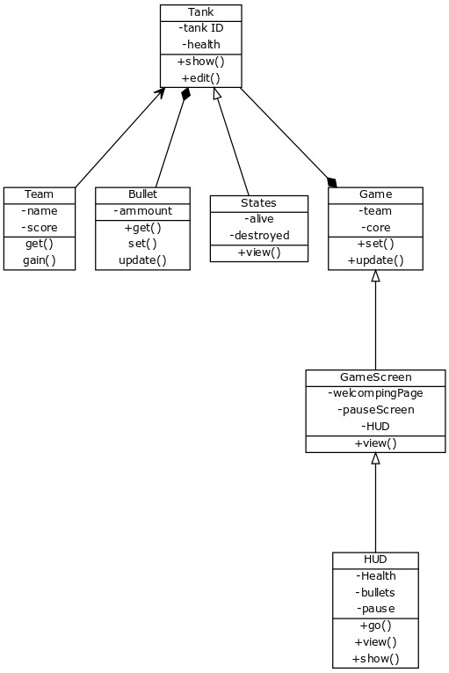

References

- Jeremy Gibson Bond Foreword by Richard Lemarchand, From Concept To Playable Game With Unity and C# (2nd Edition)
- https://yuml.me/diagram/scruffy/class/samples

